

WHO game-based education module on vaccination and immunization – International controlled trials

Immune Patrol is a new game-based educational module on vaccination and immunization developed by WHO, The Regional Office for Europe. The game-based learning module is a semi-digital learning game in which the pupils switch between playing a strategic computer game and solving analogue school assignments. The target group is pupils aged 10-12.
The digital game functions as a framework for the lessons. Pupils are divided into groups, and each group is represented in the game with a digital character. The pupils are then tasked with managing the immune system of their digital character. Each lesson is introduced through short videos and online instructions, with progress and feedback managed by the teacher with a few button-clicks. The learning module is designed to be used with minimum preparation and no prior knowledge of the topic is needed for the teachers to be able to run the modules. However, teachers should have a basic knowledge of using computers.

In its entirety, the course contains material for up to 6 lessons, each of duration of 90 minutes.
In addition, the controlled trial requires a 45-minute lesson to prepare the class, including a pre-test survey, and 20 minutes to fill in a post-test survey. Each student must fill in the pre- and post-surveys independently from others.

The lessons focus on:
- The immune system
- Transmission and outbreaks
- How vaccine works
- Vaccine preventable diseases and the benefit of vaccines
- Vaccine development
- Source criticism

WHO is pilot-testing the game Immune Patrol in different countries. The goal is to measure the impact in terms of learning and attitude formation, as well as to identify unique benefits of using a game to teach children about global health issues. In order to achieve this, the evaluation is carried out as a matched controlled trial consisting of:
- 8-12 classes playing the game Immune Patrol
- 8-12 classes use similar learning materials presented in a more traditional way without playing the actual Immune Patrol game
All classes will be tested using quizzes and psychometric self-report scales before and after the six lessons.
The classroom activities and social interactions will be observed in selected classrooms in each country. Students may be asked to share their impressions verbally.

By comparing these groups, we will be able to measure how much knowledge pupils acquire, how their attitudes to vaccinations changes, and in what ways the game component affects motivation.

Requirements for the pilot-testing and evaluation

Step 1) Gather a pilot-testing and evaluation team:

The evaluation team should preferable consist of staff from the National Immunization team, staff from WHO country Office, an external evaluation team and other local human resources (see below).

Staff from WHO country Office
The country office should support the external evaluation team in setting up the research team including reaching out to The National Immunization programme and support organizing visits of the external evaluation team prior, during and/or after the evaluation. Support recruitment of local staff, support translation of evaluation and game materials.

Staff from the National Immunization programme:
A person from the National Immunization programme should be assigned as a focal point for this work. This could be to coordinate the work incl. reaching out to Ministry of Health (MoH), Ministry of Education (MoE), educational authorities at district level, recruiting schools/teachers, ensuring preparation of teachers, etc. Consider assigning someone from MoE to be part of the coordinating work.

External evaluation team:
The evaluation will be managed by an external evaluation expert from Aarhus University, Denmark with support from WHO, The Regional Office for Europe:
- Dr. Andreas Lieberoth (Assistant professor in educational psychology, Aarhus University)
- External evaluation consultant (support the in-country pilot-testing)
- Siff Malue Nielsen (WHO Regional Office for Europe, Vaccine-preventable Diseases & Immunization (VPI))
The evaluator has designed and piloted assessment tools (online surveys/tests) to be administered by teachers according to a set schedule. The process will be managed and monitored remotely by the external evaluator. In addition, the evaluator and/or the external consultant will conduct observations and interviews in selected locations during and after the evaluation and instruct local evaluation support staff as needed. After the data has been collected it will be analyzed and the results will be presented in a report.

Local staff/human resources:
Recruitment of least one local person familiar with school traditions/policies/practices as a qualitative co-investigator who would be able to conduct observations and interviews jointly with the evaluator, as well as independently (e.g. graduate student or employee of the partner bodies).

Local assistants/observers will receive written instructions including semi-structured interview and observation guide from the evaluator. If it is not possible to meet in person, the instructions can also be given over skype. The tasks will include taking field notes and do interviews.

Not all schools and classrooms need to be observed, but lessons should be observed in some classrooms at different schools (the exact number will be defined).
Pupils and teachers (number will be defined), should be interviewed after the intervention. The minimum number needed of local assistants /observers will be assessed based on practical and geographical distribution of the local trials.

Step 2) Set-up a TC with the local pilot-testing and evaluation team to start the process

The participants should preferable consist of staff from WHO/EURO, external evaluation expert and consultant, staff from WHO CO and the focal point from the National Immunization programme.

Step 3) Seek ethical approval and recruit schools (local requirements)

Seek ethical approval:
Ethical approval must be sought in accordance with international and local standards (example of research protocol can be provided by WHO ).
A local partner must seek ethical approval according to local standards prior to the study. In some countries the need for approval can be waived, if e.g. non-biomedical research is not deemed relevant by the appropriate review board.

Recruiting schools:
A person from the National Immunization Programme and/or a consultant person should be assigned to recruit schools (example invitation letter can be provided by WHO).

Number of classes needed
- Ideal scenario: 24+ classes total (12 cases – 12 controls) grades 4-6
- Acceptable convenience sampling: 16+ classes (8 cases – 8 controls) – ideally spread across the same grade levels

Participant requirements:
- 4th-6th grade (age 10-12)
- It is important that the participating schools/classes are somewhat representative of the country’s population on pertinent variables – mainly socioeconomic status (SES), or indications of school quality, age, technology access and teacher engagement/ability.
- Half of all classes (the control group) will take the course with an emphasis on content/exercises, and the other half (the game group) will take the same course with an emphasis on game play as well as content/exercises. The two groups must therefore be matched in terms of SES and teacher ability/engagement to achieve balance between the pupils exposed to the two learning modules.

Parental consent
Local partners ensure informed consent (from pupils, parents, schools), in accordance with local ethics standards and data protection regulations. Parents may need to sign forms incl. brief descriptions of the research purpose.

Step 4) Reach out to teachers

Requirements of the teacher during the pilot-testing

Teachers will receive an information package describing the Immune Patrol. The teachers must acquaint themselves with the teaching materials by reading the teacher’s manual and getting familiar with the online game.
Teachers are responsible for administering all online data collection. Teachers will receive an information package describing the online test schedule including links to each survey. If unable to collect data online e.g. due to lack of computers/tablets, surveys can instead be printed locally.

The evaluation process:

Figure 1:
Example of an evaluation over six weeks period.
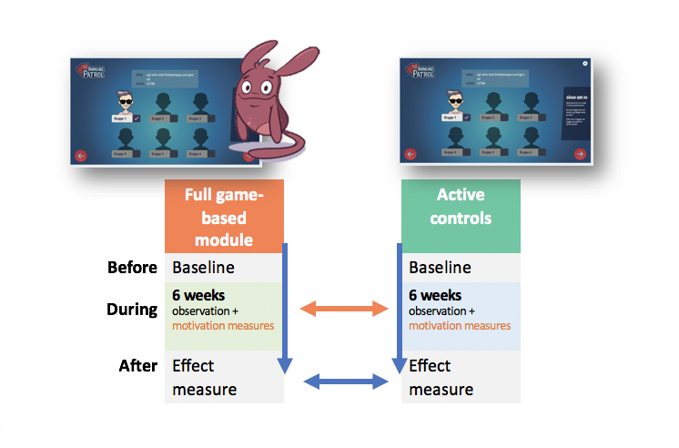
The pilot-testing and evaluation can run over one or six weeks. One model must be chosen for all classes involved in the evaluation:
- 1 week: The schools schedule all six lessons plus the introductory lesson over one-week period.
- 6 weeks: The schools schedule one lesson per week over a six weeks period. The introductory lesson is conducted during the first week or the week before.
Online survey:
- Just before the introductory lesson (same day) an online pre-survey should be filled in by all participating pupils.
- After having finalized the educational modules an online post-survey should be filled-in by all participating pupils.

Observations:
- The external evaluation team and/or local staff will conduct observations and interviews in selected locations during and after the evaluation

Step 5) Hand over research data to the external evaluation team.

The teacher handover the data collected during the pilot-testing.
The external evaluation team will draft a short report which will be translated into local language.

Relevant resources available upon request:
- Link to the game
- Draft invitation letter to schools
- Draft invitation letter to teachers
- Example of research protocol
- Link to the game: https://cgl-who.firebaseapp.com/

